Database per service design pattern
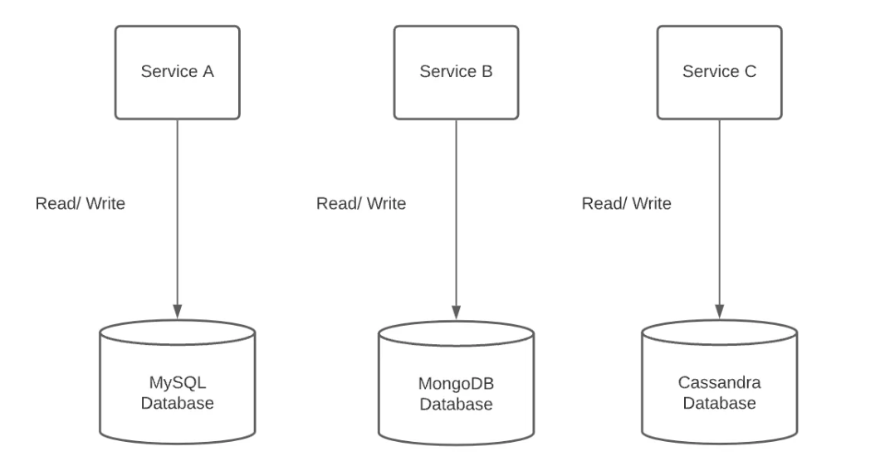

Saga Pattern

Choreography

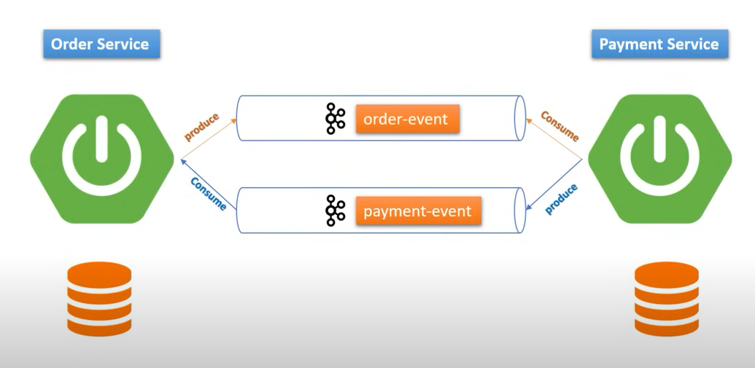

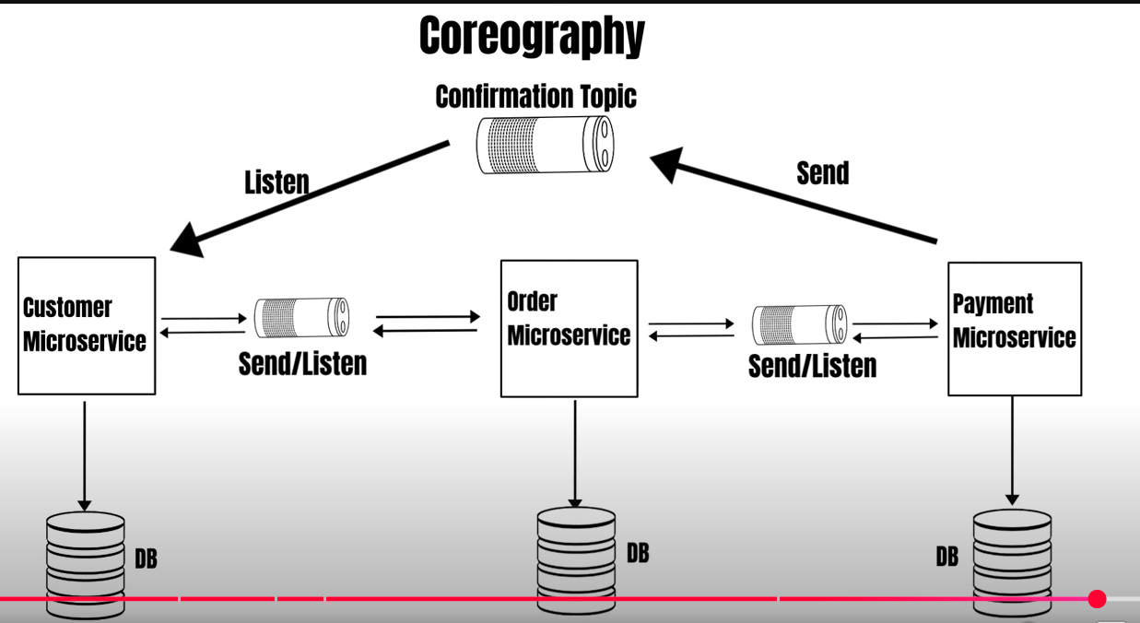

This can contain multiple other services like Inventory , Payment , Shipping
Live status to user by polling / websockets (Signal R)

Orchestrator

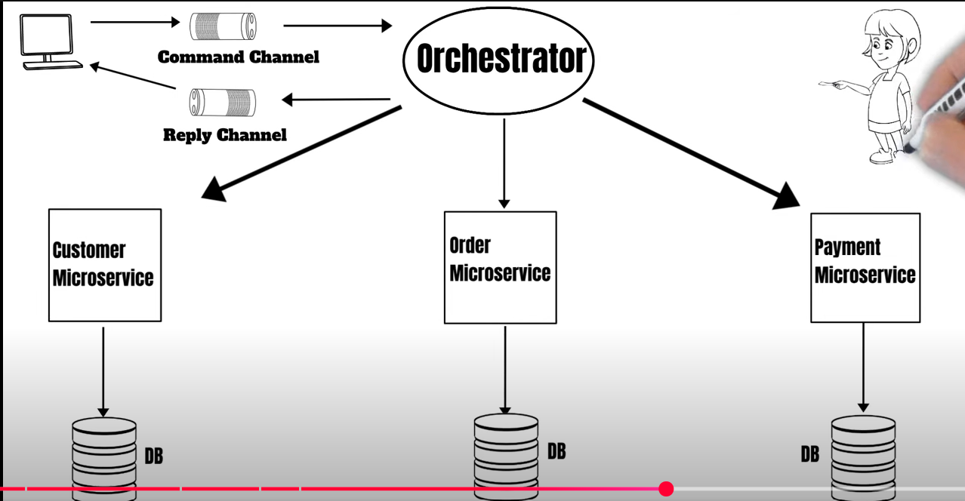

Disadvantage is orchestrator is the single point of failure .

CQRS Pattern

Command and query segregation

Practical scenario : Flipkart sale days – purchase are less than creates searches

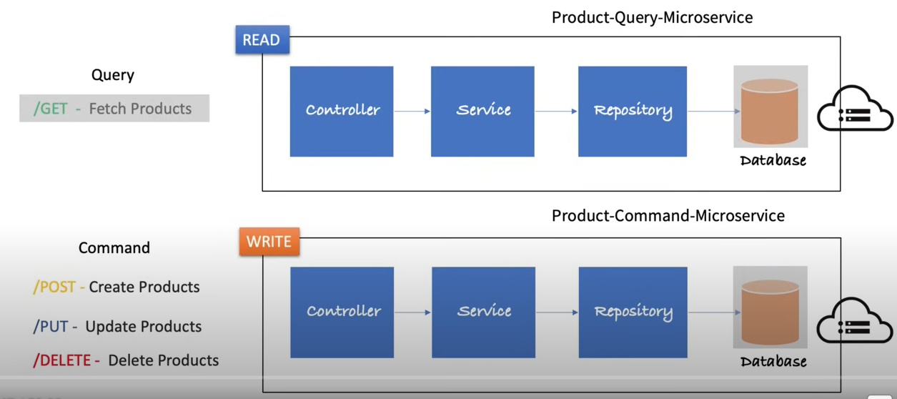

Transaction Outbox Pattern

Problem to be solved is dual write , publishing and then again writing to the database , like Kafka has failed in the below scenario.

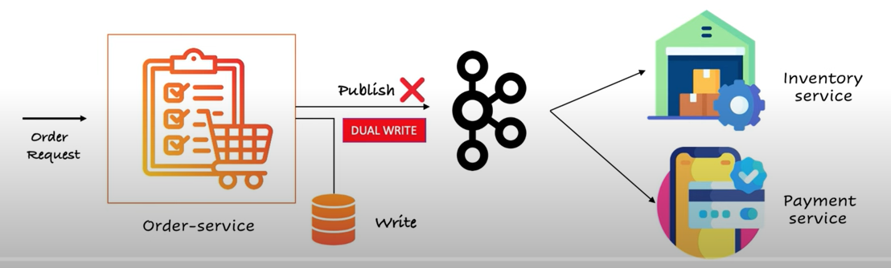

It ensures reliable message delivery in distributed systems.
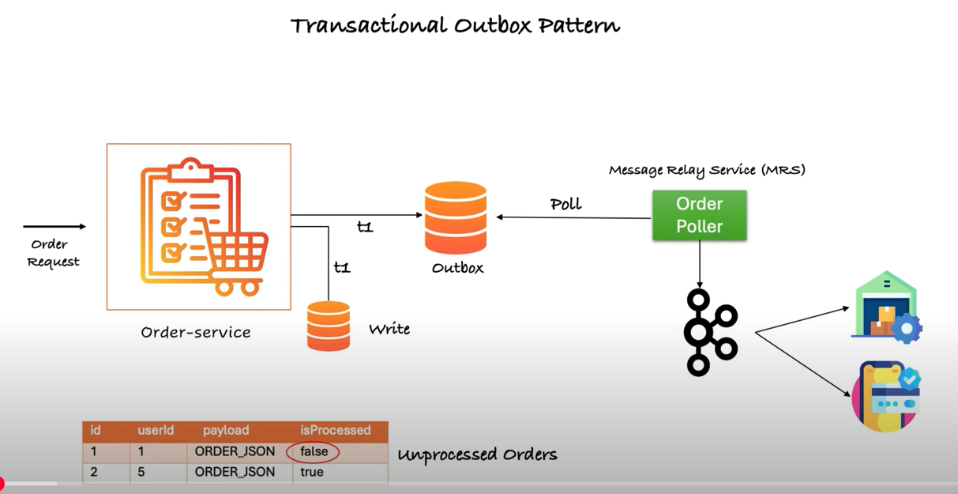

Messages are written to outbox , and from where messages are picked up by a job based on the status and published to the broker service .

Event Sourcing Design Pattern

It is a pattern where state changes are logged or stored as a sequence of immutable events instead of being stored directly in the database .

Problem below , it reflects the latest state without us knowing what has happened before .

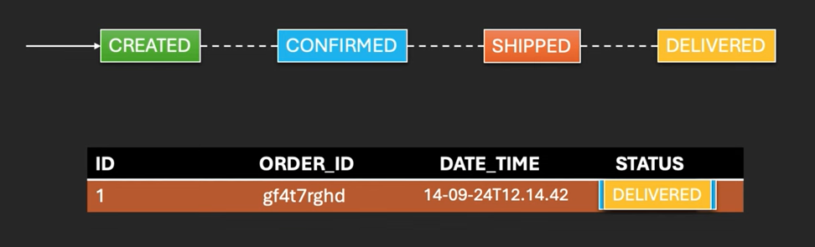

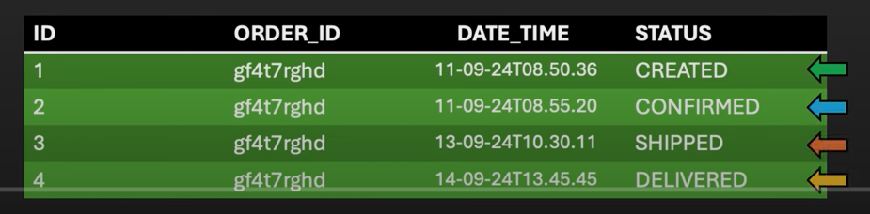

Practical scenario , ecommerce state of the order .
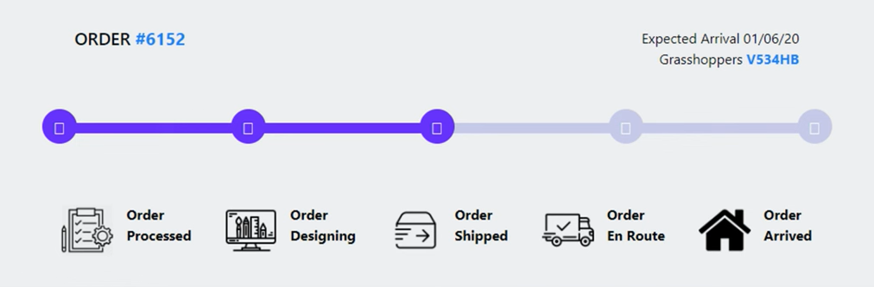

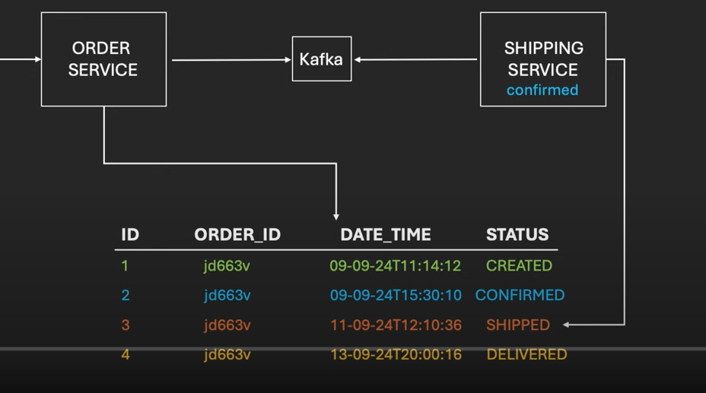

Better to use no-sql for scaling . They can also be stored in message broker like Kafka , event hub , RabitMQ etc

Aggregator Pattern

Problem , we are calling 3 micro service call to get the status . What if we have 10/15 multiple micro services . How will you handle if any service goes down .

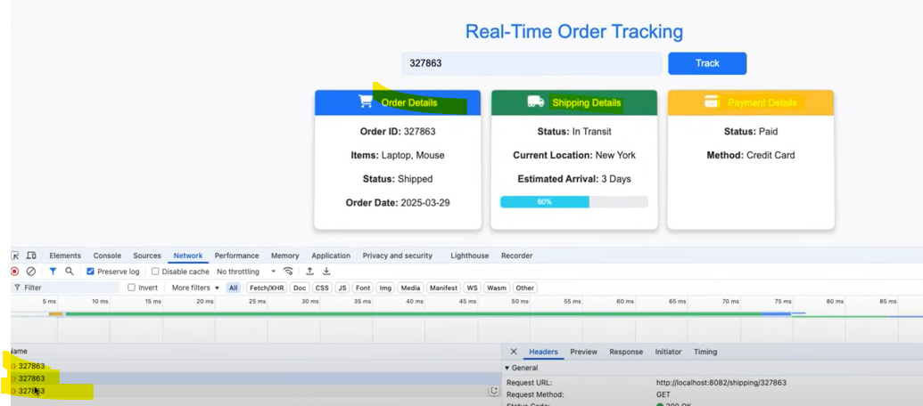

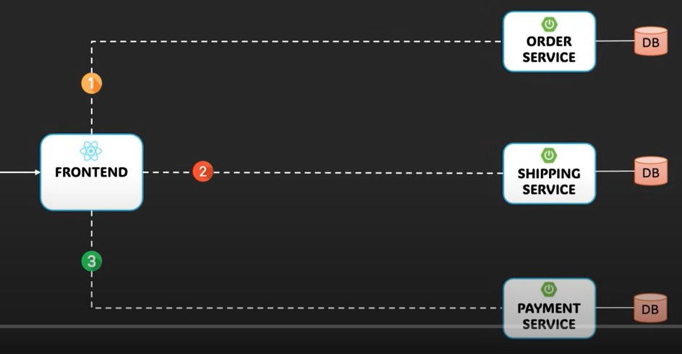

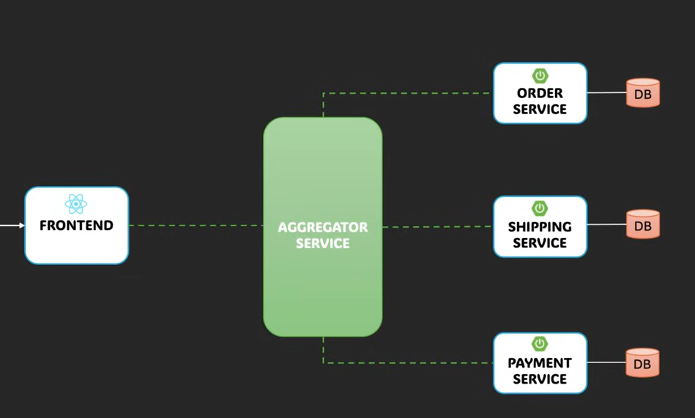

Benefits : Simplified UI , Optimized performance (parallel api calls ) , Data enrichment easy , better resilience , security enhancement .

Event-Driven Microservices : What Happens When Kafka Fails Midway?

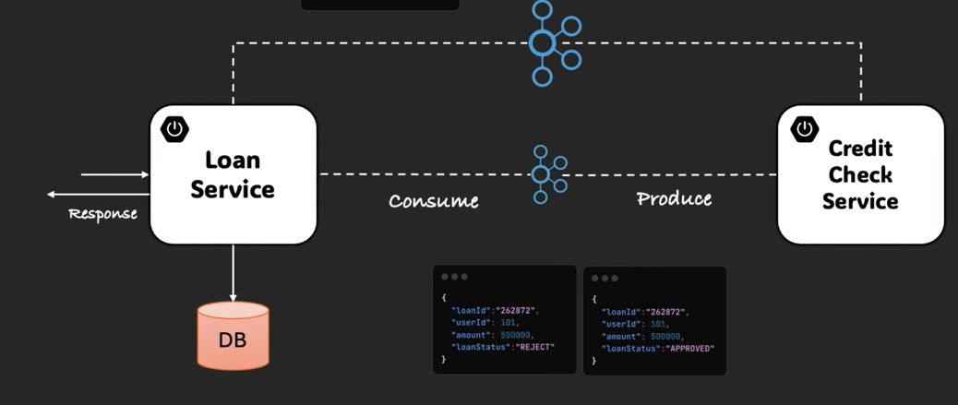

API Gateway Pattern

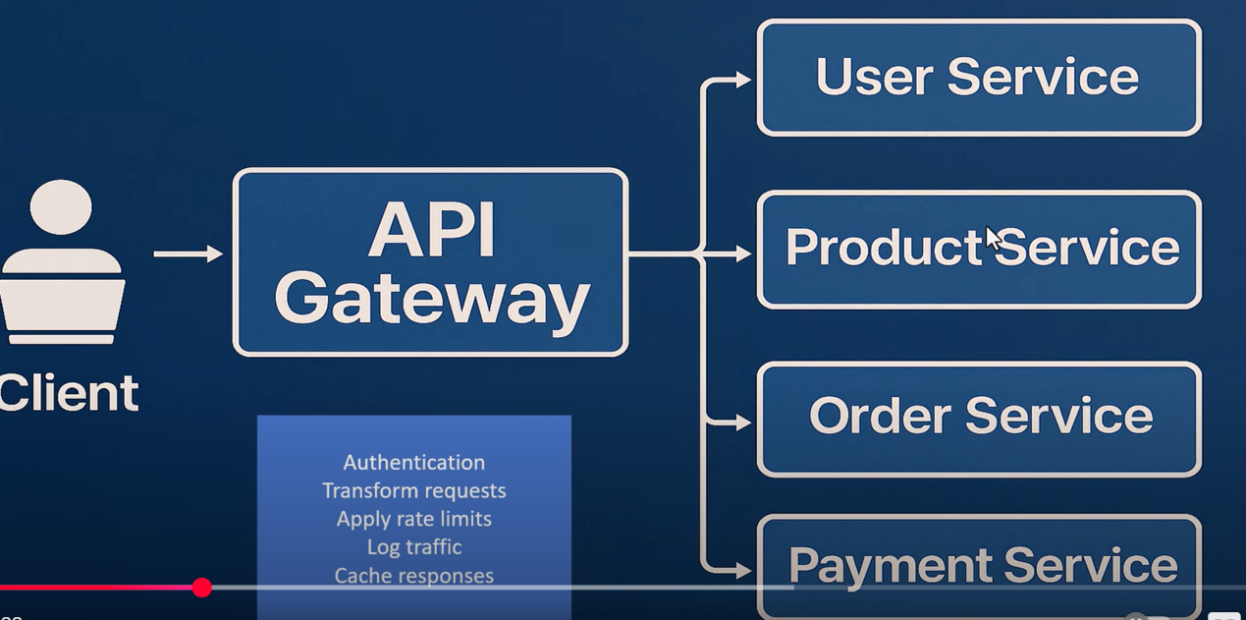

Backend For A Frontend (BFF)

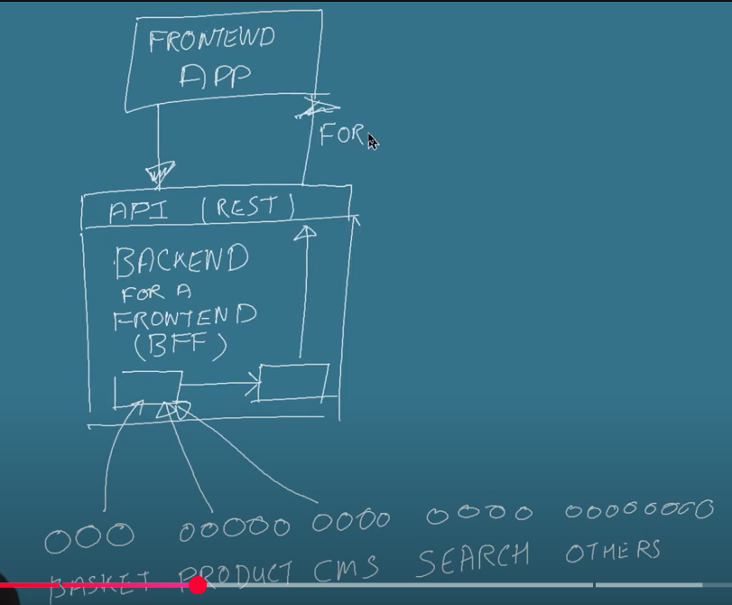

Circuit Breaker Pattern

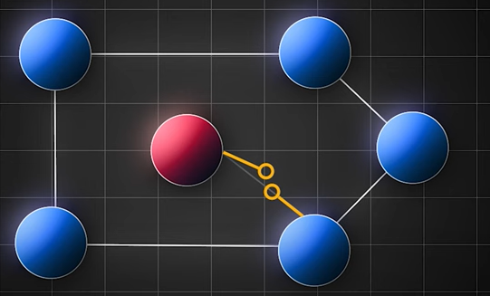
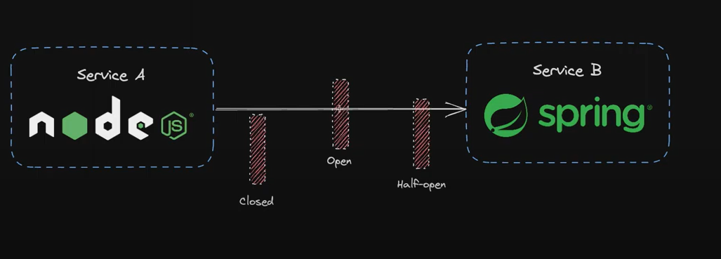

Circuit Breaker : you can implement on your own , 3 primary status for that , those are open , closed , half-open

Polly: For .NET applications, Polly is a popular library that supports the Circuit Breaker pattern and other resilience strategies, such as retries and timeouts. It provides a simple API for defining policies and applying them to service calls.

Strangler Design Pattern

This is used when we want to replace the monolithic service .

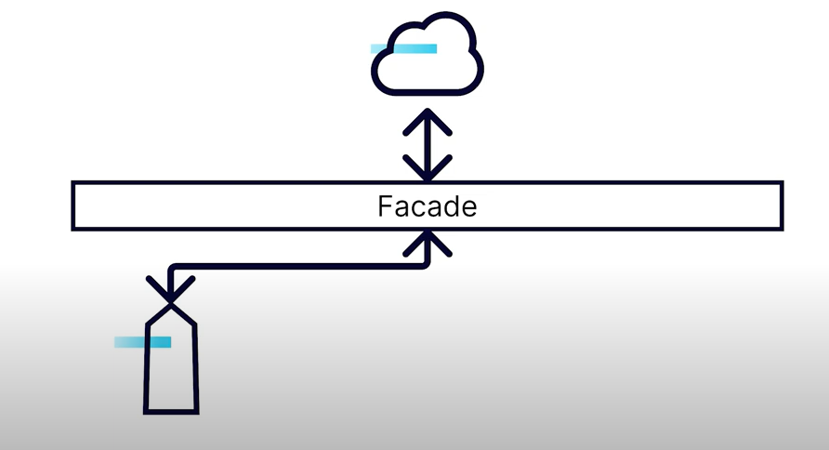

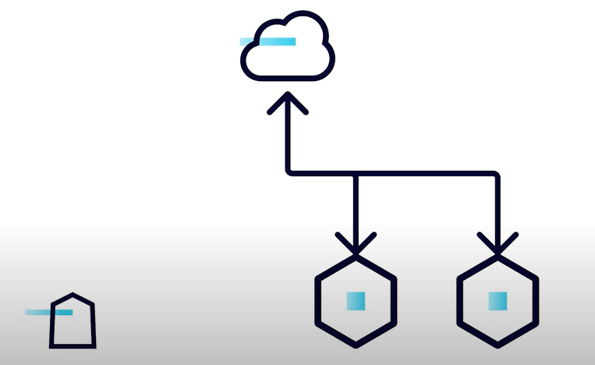

While we develop the new services , we do it one by one , and the main monolithic service keeps reducing still all the services are developed . This way we are giving continuous business value output .

